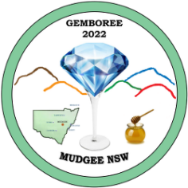
GEMBOREE 2022 MUDGEE

Presentation Dinner Saturday 16th April 2022 at 6.30pm in the Small Pavilion

A 3 Course Dinner @ $35.00 per person

Surname: ……………………………………Given Names: ……………………………………………
Address: ……………………………………………………………………………………….………………...
State: ……………………………Postcode: ………………..Phone: …………………………….…….
Your Club: …………………………………..……Number of persons attending:……………..
Email: ………………………………….……………………………………………………………………………
Please ensure this form arrives prior to 12 February 2022, all cheques are to be made to the Gem & Lapidary Council of NSW Inc. Send to PO Box 188, Orange NSW 2800.
Please tick if using EFT – to GEMBOREE Acc - BSB 032-270 Account No. 264133. Quote Surname, Initial and Dinner in the reference field for EFT

Any Queries please contact Marcia Hill - Mobile 0477 770 441 or email snoopy39@bigpond.com

