Standard Round Brilliant with Continuous Girdle
Section O 8A.1 Coloured Cubic Zirconia
Section I 8A.2 Coloured Cubic Zirconia
Section N 8A.3 Coloured Cubic Zirconia

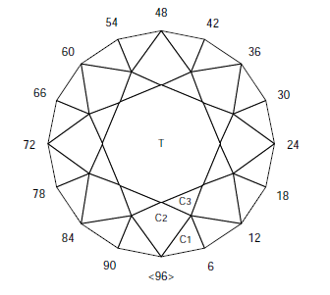 |  |  |  | 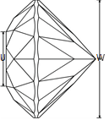 |  |  | 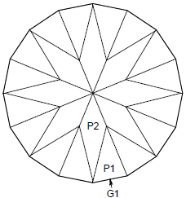
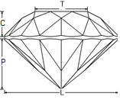 |  |  |  |  | Angles for R.I. = 2.160  57 + rolled girdle  8-fold, mirror-image symmetry  96 index  L/W = 1.000 T/W = 0.593 U/W = 0.593  P/W = 0.461 C/W = 0.164  Vol. /W³ = 0.225
 | PAVILION
 | P1 | 45.00° | 03-09-15-21-27-33-39-45 |  |  | Cut to TCP
 |  |  | 51-57-63-69-75-81-87-93
 | G1 | 90.00° |  |  |  | Cut to size, “rolled girdle”
 | P2 | 43.00° | 96-12-24-36-48-60-72-84 |  |  | Cut to Girdle
 | CROWN
 | C1 | 44.00° | 03-09-15-21-27-33-39-45 |  |  | Set girdle thickness
 |  |  | 51-57-63-69-75-81-87-93
 | C2 | 37.00° | 96-12-24-36-48-60-72-84 |  |  | Cut to Girdle
 | C3 | 22.00° | 06-18-30-42-54-66-78-90 |  |  | Cut to meet C1, C2
 | T | 0.00° | Table |  |  | Cut to meet C2, C3

Standard Round Brilliant with Faceted Girdle
Section O 8B.1 Australian Amethyst Specified Size: 8 mm
Section I 8B.2 Australian Amethyst Specified Size: 7 mm
Section N 8B.3 Australian Amethyst

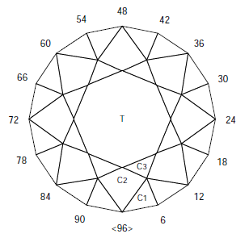 | 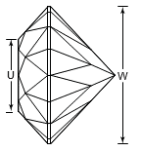
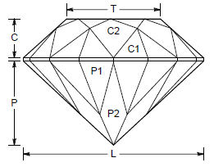 |  | Angles for R.I. = 1.540  57 + 16 girdles = 73 facets  8-fold, radial symmetry  96 index  L/W = 1.000 T/W = 0.519 U/W = 0.519  P/W = 0.467 C/W = 0.216  Vol. /W³ = 0.240

PAVILION
P1 | 45.00° | 03-09-15-21-27-33-39-45 | Cut to TCP
 |  | 51-57-63-69-75-81-87-93
G1 | 90.00° | 03-09-15-21-27-33-39-45 | Set Size
 |  | 51-57-63-69-75-81-87-93
P2 | 43.00° | 96-12-24-36-48-60-72-84 | Cut to Girdle
CROWN
C1 | 47.00° | 03-09-15-21-27-33-39-45 | Cut to establish girdle
 |  | 51-57-63-69-75-81-87-93
C2 | 42.00° | 96-12-24-36-48-60-72-84 | Cut to Girdle
C3 | 27.00° | 06-18-30-42-54-66-78-90 | Meet C1, C2
T | 0.00° | Table | Meet C2, C3

Standard oblong step cut with cut corners
Section O 9A.1 Australian Citrine Specified Size: 12 mm x 14 mm
Section I 9A.2 Australian Citrine Specified Size: 11 mm x 13 mm
Section N 9A.3 Coloured Quartz
Section J 9A.4 Coloured Quartz
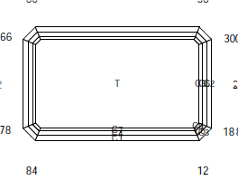 | 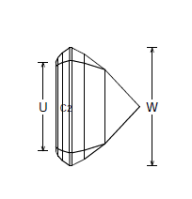 | 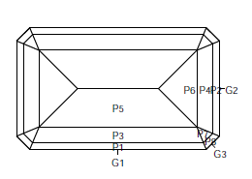

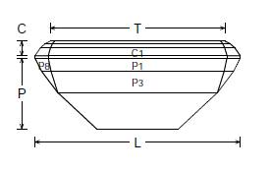 | Angles for R.I. = 1.540  45 + 8 girdles = 53 facets  2-fold, mirror-image symmetry  96 index  L/W = 1.666 T/W = 1.400 U/W = 0.620  P/W = 0.408 C/W = 0.136  Vol. /W³ = 0.561

PAVILION |  |  |  |  | CROWN
G1 | 90.00° | 96-48 | Set width |  | C1 | 55.00° | 96-48 | Set girdle width
G2 | 90.00° | 24-72 | Set length |  | C2 | 55.00° | 24-72 | Level girdle
P1 | 63.00° | 96-48 | Cut to approx 75% of the height of the stone |  | C3 | 55.00° | 12-36-60-84 | Level girdle
P2 | 63.00° | 24-72 | Meet at P1, Girdle |  | C4 | 42.00° | 96-48 | Cut to diagram
P3 | 53.00° | 96-48 | Cut to diagram |  | C5 | 42.00° | 24-72 | Meet C5, C6, C8
P4 | 53.00° | 24-72 | Cut to meet P3 |  | C6 | 42.00° | 12-36-60-84 | Cut as required
P5 | 43.00° | 96-48 | Cut to diagram, P3 should be 2x P1 wide |  | C7 | 26.00° | 96-48 | Cut to leave C4 half the width of C1
P6 | 43.00° | 24-72 | Cut to meet P5 |  | C8 | 26.00° | 24-72 | Cut to leave C5 half the width of C2
P7 | 62.86° | 12-36-60-84 | Cut as required |  | C9 | 26.00° | 12-36-60-84 | Cut as required
P8 | 53.21° | 12-36-60-84 | Cut as required |  | T | 0.00° | Table | Cut to diagram
G3 | 90.00° | 12-36-60-84 | Cut to level girdle

The Meridian Cut
Attributed to the late Jack Bushby
Section O 10.1 Colourless Topaz
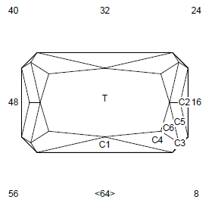 | 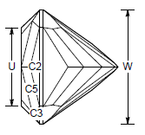 | 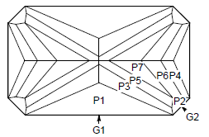

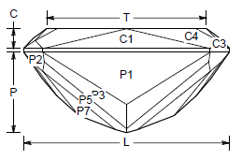 | Angles for R.I. = 1.610  49 + 8 girdles = 57 facets  2-fold, mirror image symmetry  64 index  L/W = 1.666 T/W = 1.296 U/W = 0.685  P/W = 0.651C/W = 0.162  Vol. /W³ = 0.663

PAVILION |  |  |  |  | CROWN
G1 | 90.00° | 64-32 |  |  | C1 | 46.00° | 64-32
G2 | 90.00° | 08-16-24-40-48-56 |  |  | C2 | 46.00° | 16-48
P1 | 55.00° | 64-32 |  |  | C3 | 68.42° | 08-24-40-56
P2 | 55.00° | 08-16-24-40-48-56 |  |  | C4 | 36.00° | 01-31-33-63
P3 | 49.50° | 01-31-33-63 |  |  | C5 | 36.00° | 15-17-47-49
P4 | 49.50° | 15-17-47-49 |  |  | C6 | 25.00° | 13-19-45-51
P5 | 43.25° | 03-29-35-61 |  |  | T | 00.00° | Table
P6 | 43.25° | 13-19-45-51
P7 | 39.00° | 05-27-37-59

Centralian Star
Bob Kay
Section I 10.2 Colourless Topaz
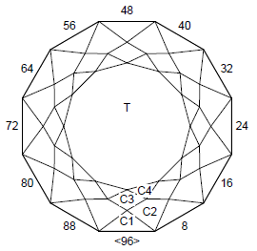 | 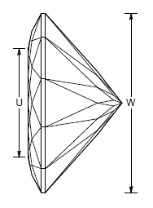 | 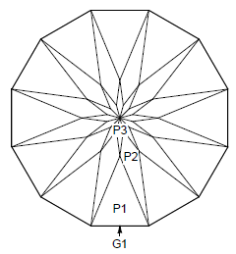

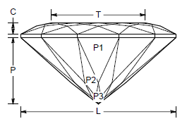 |  |  |  | Angles for R.I. = 1.610  85 + 12 girdles = 97 facets  12-fold, radial symmetry  96 index  L/W = 1.000 T/W = 0.605 U/W = 0.605  P/W = 0.429 C/W = 0.074  Vol. /W³ = 0.179
 | PAVILION
 | P1 | 42.00° | 96-08-16-24-32-40 |  | Cut to TCP
 |  |  | 48-56-64-72-80-88
 | G1 | 90.00° | 96-08-16-24-32-40 |  | Establish size
 |  |  | 48-56-64-72-80-88
 | P2 | 40.00° | 04-12-20-28-36-44 |  | Cut to Girdle
 |  |  | 52-60-68-76-84-92
 | P3 | 38.00° | 96-08-16-24-32-40 |  | Cut to P1
 |  |  | 48-56-64-72-80-88
 | CROWN
 | C1 | 28.00° | 96-08-16-24-32-40 |  | Establish Girdle
 |  |  | 48-56-64-72-80-88
 | C2 | 22.00° | 04-12-20-28-36-44 |  | Meet Girdle
 |  |  | 52-60-68-76-84-92
 | C3 | 12.00° | 96-08-16-24-32-40 |  | Meet C1
 |  |  | 48-56-64-72-80-88
 | C4 | 08.00° | 04-12-20-28-36-44 |  | Meet C2
 |  |  | 52-60-68-76-84-92
 | T | 0.00° | Table |  | Meet C3, C4
JBCROSS
The late Jack Bushby
Section N 10.3 Colourless Man-made Cubic Zirconia
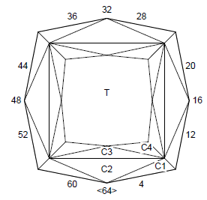 |  |  |  | 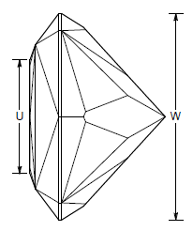 |  |  |  | 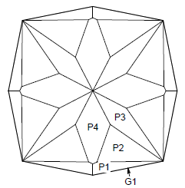
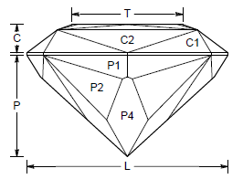 |  |  |  |  |  | Angles for R.I. = 2.160  49 + 8 girdles = 57 facets  8-fold, radial symmetry  64 index  L/W = 1.000 T/W = 0.552 U/W = 0.552  P/W = 0.504 C/W = 0.140  Vol. /W³ = 0.257
PAVILION
G1 | 90.00° | 02-14-18-30-34-46-50-62 |  |  | Size Stone
P1 | 58.50° | 02-14-18-30-34-46-50-62 |  |  | Establish girdle to about 75% of stone depth
P2 | 47.00° | 03-13-19-29-35-45-51-61 |  |  | Meet at Girdle
P3 | 40.50° | 08-24-40-56 |  |  | Meet at Girdle
P4 | 42.50° | 64-16-32-48 |  |  | Meet at PCP. Cut to diagram
CROWN
C1 | 55.00° | 02-14-18-30-34-46-50-62 |  |  | Establish Girdle
C2 | 37.00° | 64-16-32-48 |  |  | Meet at Girdle
C3 | 20.00° | 64-16-32-48 |  |  | Cut to meet C1, C2
C4 | 14.00° | 01-15-17-31-33-47-49-63 |  |  | Cut to meet C1, C2, C3
T | 00.00° | Table |  |  | Cut to meet C3, C4

Topaz Twinkler-96
Bob Kay
Section J 10.4 Colourless Topaz
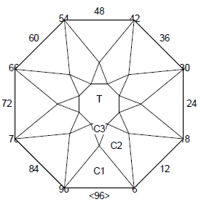 | 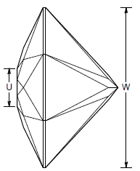 | 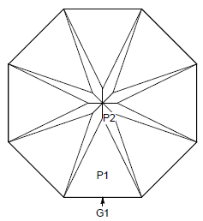

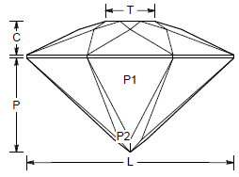 |  |  | Angles for R.I. = 1.610  41 + 8 girdles = 49 facets  8-fold, radial symmetry  96 index  L/W = 1.000 T/W = 0.239 U/W = 0.239  P/W = 0.454 C/W = 0.162  Vol. /W³ = 0.204
PAVILION
P1 | 43.00° | 96-12-24-36-48-60-72-84 |  |  | Cut to TCP
G1 | 90.00° | 96-12-24-36-48-60-72-84 |  |  | Set size
P2 | 40.00° | 06-18-30-42-54-66-78-90 |  |  | Cut to meet girdle and form PCP
CROWN
C1 | 26.00° | 96-12-24-36-48-60-72-84 |  |  | Cut to level girdle
C2 | 21.50° | 06-18-30-42-54-66-78-90 |  |  | Meet at Girdle
C3 | 17.00° | 96-12-24-36-48-60-72-84 |  |  | Meet at C1
T | 00.00° | Table |  |  | Meet C2, C3

Montezuma Concavia – Concave Cut
Modified by Paul Sabolta 2018 for Concave
From an original design by Arya Akhavan 2013
Section O 10.5 Blue Man-made Cubic Zirconia
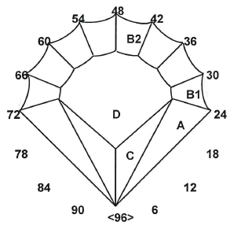 | 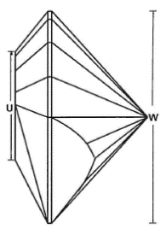 | 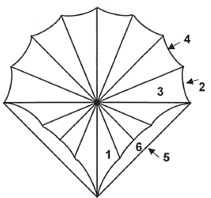

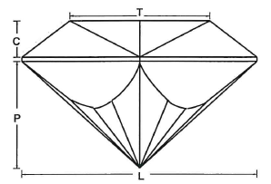 | Angles for R.I. = 2.160  31 + 10 girdles = 41 facets  1-fold, mirror-image symmetry  96 index  L/W = 1.000 T/W = 0.599 U/W = 0.513  P/W = 0.457 C/W = 0.155  Vol. /W³ = 0.180

PAVILION
1 | 43.00° | 03-09-15-21-27-33-39-45-51-57-63-69-75-81-87-93 | Preform, Cut to TCP (Flat Facets)
2 | 90.00° | 27-33-39-45-51-57-63-69 | Preform, Set stone size (8 Flat Facets) Minimum 10mm
3 | 43.00° | 03-09-15-21-27-33-39-45-51-57-63-69-75-81-87-93 | Concave (16 Concave Facets) Form PCP  (Mandrel size, cutters choice to achieve meetpoints)
4 | 90.00° | 27-33-39-45-51-57-63-69 | Concave (8 Concave Facets) Form PCP  (Mandrel size, cutters choice to achieve meetpoints)
5 | 90.00° | 12-84 | Meet 3,4
6 | 70.00° | 12-84 | Level girdle
CROWN
A | 40.00° | 12-84 | Set girdle thickness to suit
B1 | 40.00° | 27-33-39-45-51-57-63-69 | Level girdle (8 Flat Facets)
B2 | 40.00° | 27-33-39-45-51-57-63-69 | Concave (8 Concave Facets)  (Mandrel size, cutters choice to achieve meetpoints)
C | 34.67° | 11-85 | Meet A, 3
D | 00.00° | Table | Meet A, C, B2
English Rose
Maurice Jones, Salisbury East, SA
Section O 11.1 Colourless Quartz
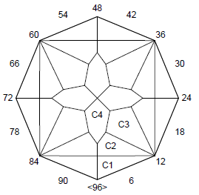 | 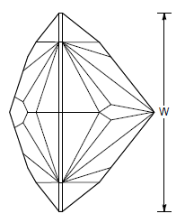 | 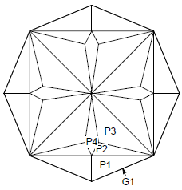

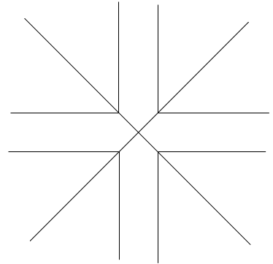 | 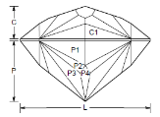 | Angles for R.I. = 1.540  52 + 8 girdles = 60 facets  4-fold, radial symmetry  96 index  L/W = 1.000  P/W = 0.465 C/W = 0.251  Vol. /W³ = 0.214

Note: Facets on 43.00° do not meet at culet,
as shown above.

PAVILION
P1 | 54.00° | 06-18-30-42-54-66-78-90 | Cut to TCP
G1 | 90.00° | 06-18-30-42-54-66-78-90 | Set size, level girdle
P2 | 50.00° | 07-17-31-41-55-65-79-89 | Meet P1, Girdle
P3 | 43.00° | 11-13-35-37-59-61-83-85 | Meet P1, P2, G
P4 | 38.40° | 96-24-48-72 | Meet P1
CROWN
C1 | 40.80° | 06-18-30-42-54-66-78-90 | Cut to establish girdle
C2 | 33.40° | 08-16-32-40-56-64-80-88 | Cut to meet Girdle
C3 | 30.00° | 12-36-60-84 | Cut to meet C1, C2 at Girdle
C4 | 18.20° | 96-24-48-72 | Cut to 50% of width of stone

Vesper
Maurice Jones, Salisbury East, SA
Section I 11.2 Colourless Man-made Cubic Zirconia
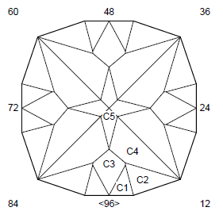 | 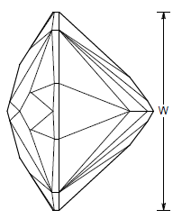 | 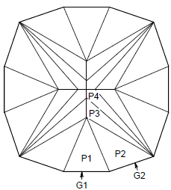

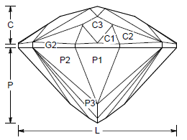 | Angles for R.I. = 2.160  56 + 12 girdles = 68 facets  4-fold, radial symmetry  96 index  L/W = 1.000  P/W = 0.476 C/W = 0.238  Vol. /W³ = 0.257

PAVILION
G1 | 90.00° | 96-24-48-72 | Set size
G2 | 90.00° | 05-19-29-43-53-67-77-91 | Cut as per diagram
P1 | 47.30° | 96-24-48-72 | Cut to TCP
P2 | 45.00° | 05-19-29-43-53-67-77-91 | Meet P1, Girdle
P3 | 41.00° | 08-16-32-40-56-64-80-88 | Meet Girdle
P4 | 39.50° | 12-36-60-84 | Meet G, P3. Form PCP
CROWN
C1 | 33.50° | 01-23-25-47-49-71-73-95 | Establish Girdle
C2 | 33.00° | 04-20-28-44-52-68-76-92 | Establish Girdle
C3 | 32.50° | 96-24-48-72 | Meet Girdle
C4 | 22.82° | 10-14-34-38-58-62-82-86 | Meet Girdle
C5 | 15.00° | 96-24-48-72 | Meet C3

Petunia
The Late Jack Bushby
Section N 11.3 Coloured Man-made Cubic Zirconia
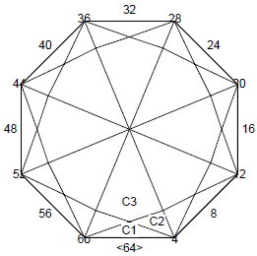 | 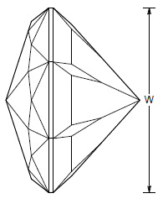 | 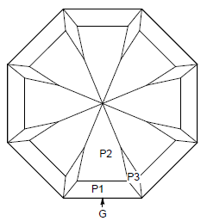

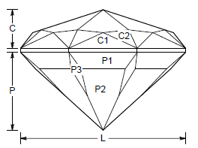 | Angles for R.I. = 2.160  56 + 8 girdles = 64 facets  8-fold, radial symmetry  64 index  L/W = 1.166 T/W = 0.519 U/W = 0.620  P/W = 0.583 C/W = 0.194  Vol. /W³ = 1.147

PAVILION
P1 | 48.00° | 64-08-16-24-32-40-48-56 | Cut to TCP
G | 90.00° | 64-08-16-24-32-40-48-56 | Set size
P2 | 42.17° | 64-08-16-24-32-40-48-56 | Cut to leave P1 approx 1/3 original
P3 | 42.00° | 04-12-20-28-36-44-52-60 | Cut to meet P1, Girdle
CROWN
C1 | 52.00° | 64-08-16-24-32-40-48-56 | Cut to establish girdle
C2 | 39.90° | 02-06-10-14-18-22-26-30-34-38-42-46-50-54-58-62 | Cut to meet Girdle
C3 | 18.00° | 64-08-16-24-32-40-48-56 | Cut to meet C1, C2

